**CSE230 - Discrete Mathematics (Sec-2)**

Quiz #3

Total Marks: 25 Time: 50 minutes

**Please read the questions carefully before attempting to answer them.**

|  |  |
| --- | --- |
| **NAME:** | **ID:** |

1. For which  the 5𝑡ℎ expansion member equals ?  **[6]**

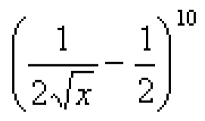

1. Find the coefficient of 𝑥5𝑦8 in (𝑥 + 𝑦)13 .  **[4]**

1. How many unique ways are there to arrange the letters in the word PRIOR? **[4]**

1. How many integers, greater than 999 but not greater than 4000, can be formed with the digits 0, 1, 2, 3 and 4, if repetition of digits is allowed? **[5]**

1. An event manager has ten patterns of chairs and eight patterns of tables. In how many

ways can he make a pair of table and chair? **[3]**

1. A box contains three pairs of socks colored red, blue, and green, respectively. If the socks are chosen without looking, how many socks must be drawn to guarantee at least one matching pair? Explain in a few words. **[3]**

**BONUS QUESTION:**

A bag contains 3 white balls and 2 black balls. Another bag contains 2 white and 4 black balls. A bag and a ball are picked random. What is the probability that the ball will be white? **[4]**